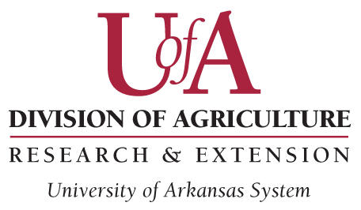Request for Modification

Ag-IACUC Use Only
Protocol Number: Click or tap here to enter text. Date Received: Click or tap here to enter text.
Approval Date: Click or tap here to enter text. End Date: Click or tap here to enter text.

Instructions:
- This form is required for modifications (other than personnel) of an Animal Use Protocol (AUP) which is currently
- approved by the Ag-IACUC.
  - Major modifications that would significantly change either objectives or design will require a new AUP.
- In completing this modification request, please:
  - Explain the modification(s) so it can be clearly understood how it (or they) fit in the Experimental Design
as described in the AUP.
  - It is preferred that this document explain the proposed procedure(s) adequately so that the reviewers
do not need a copy of the AUP. However, if necessary refer to the AUP as needed so the reviewers can
clearly understand the proposed modification(s).
  - The deadline for getting this form to agiacuc@uark.edu is 12:00 midnight on the SECOND WEDNESDAY
of every month.

Protocol #: Click or tap here to enter text.

Project Title of Original Protocol: Click or tap here to enter text.

Principal Investigator: Click or tap here to enter text. Telephone: Click or tap here to enter text.

Objective of the Modification: Click or tap here to enter text.

Requested Changes:

- Animals:
  - Change in Species: Click or tap here to enter text.
  - Number of Animals required for this modification: Click or tap here to enter text.

- Methods:
  - Change in Housing: Click or tap here to enter text.
  - Change in Experimental Design: Click or tap here to enter text.
  - Changes in Non-Surgical Procedures: Click or tap here to enter text.
  - Changes in Surgical Procedures: Click or tap here to enter text.
  - Changes in Euthanasia: Click or tap here to enter text.
  - Other: Click or tap here to enter text.

